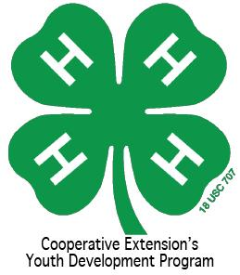
North Carolina 4-H Opportunities

Many of the applications and forms referred to below can be found online at: http://www.nc4h.org Click on “Youth,” then “Awards and Incentives Program”

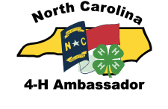
4-H Ambassadors Applicants must be at least 13 years old and a 4-H member for two years as of January 1. 4-H’ers may earn Bronze, Silver, Gold and Emerald Ambassador levels by completing workshops and a portfolio for each level. This program strengthens and expands upon 4-H Ambassadors' current leadership abilities and allows them to serve as positive role models for younger youth.
Contact: Shannon McCollum, shannon_mccollum@ncsu.edu

4-H Portfolios This is an accumulation three years of 4-H project work in a major project area. Records are submitted in age categories of 13-15 and 16-18. These books are due in the county 4-H office in early February. State winners receive cash awards.
Contact: Shannon McCollum, shannon_mccollum@ncsu.edu

4-H Clubs 4-H Clubs are a great way to supports long-term youth development and build community amongst our youth, while instilling essential life skills such as leadership, commitment, and nurturing relationship. Whether they are working together on projects in Science & Technology, or focusing their club efforts on environmental awareness, 4-H Club youth learn the importance of becoming engaged in the community, country, and world.
Contact: Shannon McCollum, shannon_mccollum@ncsu.edu

4-H Entertains 4-H Entertains is a talent showcase that occurs in conjunction with District Activity Day (DAD). Each county may register two acts to perform at DAD. Acts will then be selected to perform at the state talent show at 4-H Congress in June. County acts perform at County Activity Day and will be selected to perform at District Activity Day.
Contact: Mark Dearmon, mark_dearmon@ncsu.edu

4-H Group Awards The 2 group awards that clubs and other 4-H groups can apply for each year are The NC 4-H Community Service award (based on community service projects completed by a 4-H group) and The 4-H Electric Group Award. One per county is eligible for State Competition. Applications must be received by the State 4-H Office by March 1.
Contact: Shannon McCollum, shannon_mccollum@ncsu.edu

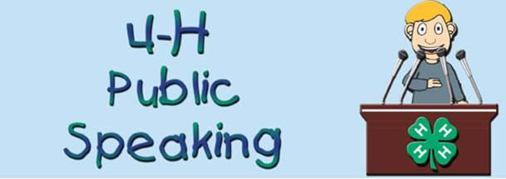
4-H Presentations and Public Speaking This competition allows you the opportunity to present information by demonstration or illustrated talk for competition. The time limit is generally between 5 and 12 minutes, with specific time regulations in specific categories. 4-H’ers are selected to compete at district competition through county competitions.
Contact: Shannon McCollum, shannon_mccollum@ncsu.edu

4-H Project Records - records highlight what 4-H’ers have learned and done in a specific project area for a period of 12 months. The books are judged in age categories of: 9-10, 11-12, 13-15 and 16-18, Cloverbuds (ages 5-8 years old as of January 1) may also turn in a project record book, but these books are not judged. Project Record books are due in the County 4-H office at the Volunteer Leader Association (VLA) meeting in January. The 2 top county winners in each curriculum area are submitted to Raleigh for district competition.
Contact: Shannon McCollum, shannon_mccollum@ncsu.edu

4-H International Programs – Designed for 4-H youth who want the experience of another culture and to gain a global perspective. Youth must be at least 4-H Age 17 and not over 21 years of age.
Contact: Shannon McCollum, shannon_mccollum@ncsu.edu

Application, Interview, Resume and Essay (AIRE). Due in State 4-H Office May 15. Applications must be at least 14 years old as of January 1. This program is used to select the delegations to attend National 4-H Congress, National 4-H Conference and the International Leadership Conference. Participants must complete a two-page application and submit a resume of no more than two pages and an Essay on How 4-H Has Impacted Their Life. The resume should highlight the 4-H’ers achievements, project work and leadership throughout their career. The County 4-H Agent must sign off on the application before it is submitted. Interviews are held in conjunction with NC 4-H Congress. Winners are announced during 4-H Congress.
Contact: Mitzi Downing, mitzi_downing@ncsu.edu
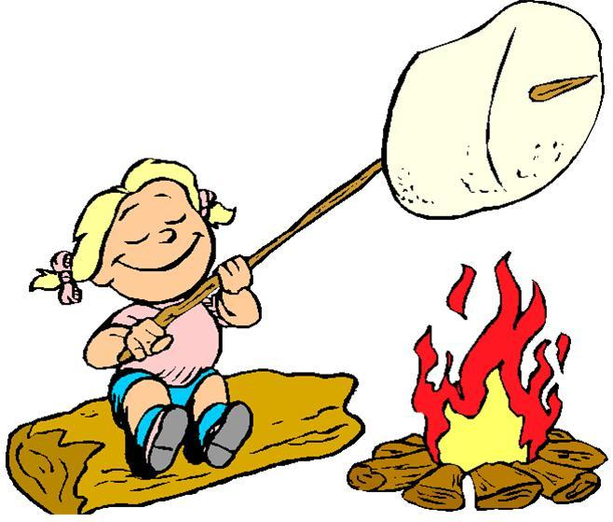
CAMPS http://www.nc4hcamps.org/ The NC 4-H Camping Program offers excellent camp opportunities for 4-H’ers of all ages at three great camps (Betsy-Jeff Penn 4-H Center, the Eastern 4-H Center and Millstone 4-H Camp). Counties may elect to take a delegation (group) of 4-H’ers (ages 8-14) to a week of “traditional 4-H camp”. The number of 4-H camp sessions and dates are announced the year before so that 4-H Agents can arrange “multiple county camping groups” if desired. 4-H group’s registration is in the fall of each year for the next summer. 4-H “Specialty Camps” are also offered – each of these unique camps is built around a theme (Cloverbud, Marine Science & Sailing, Fur, Fish & Game Rendezvous, Horsemanship Camp, etc.). Additionally opportunities are provided for older 4-H’ers (ages 15-17) to spend a week as an LIT (Leader in Training). Outstanding 4-H’ers are strongly encouraged to become an LIT and, eventually, apply to be a 4-H Camp Staff member (age 18+).
Contacts: Dave Herpy (djherpy@ncsu.edu) or Larry Hancock (larry_hancock@ncsu.edu)
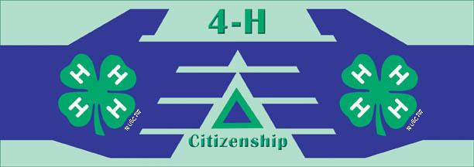
Citizenship NC Focus Hands-on workshops, panel discussions, distinguished speakers and open discussion will help youth discover how government impacts your everyday life, and how you can impact government in return. 4-H’ers will learn about state government, learn about working with public officials, hear from prominent NC officials and visit legislators.
Contact: Sarah Kotzian, sarah_kotzian@ncsu.edu

College Scholarships High school seniors may apply for 4-H scholarships. The application must be postmarked by February 1. One application form is completed if applying for one or more scholarships. Several of these scholarships are restricted to youth that meet certain criteria. The County 4-H office receives information on these scholarships in early December. Scholarship awards range in amounts from $500 to $2000.
Contact: Shannon McCollum, shannon_mccollum@ncsu.edu

Creating and Piloting Curriculum. Each year, content specialists take cutting edge research and turn it into relatable curriculum for use in schools, afterschool programs, camps, and other non-formal education settings. Curriculum content themes include Leadership/Citizenship, Agriculture/Livestock, Health/Life Skills, STEM, etc. Opportunities exist for agents, volunteers, educational partners, and youth to participate in creating and piloting curricula. Each curricula is built using a content specialist, an advisory team, and an evaluation specialist to make sure it meets rigorous standards to meet the needs of K-12 partners and 4-H. Curriculum provides the content from which 4-H programs are developed.
Contact: Amy Chilcote, amy_chilcote@ncsu.edu

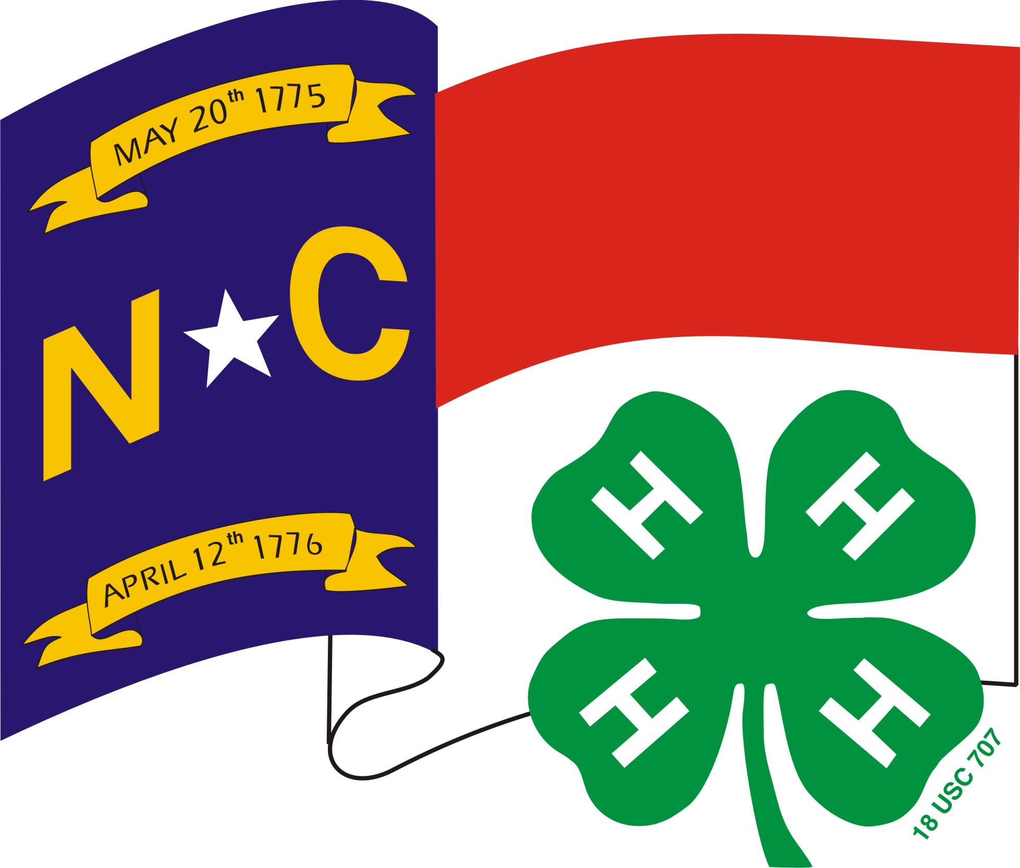
Dairy Events http://www.cals.ncsu.edu/an_sci/extension/dairy/4-H/4hdairy.htm Events focused on dairy education include: dairy judging, dairy quiz bowl, dairy skill-a-thon, dairy poster contest, numerous dairy shows and national 4-H dairy conference.
Contact: shannon_davidson@ncsu.edu

Entomology Events http://ipm.ncsu.edu/4-H/ Events focused on Entomology education include: presentations, essays, insect collections.
Contact: Liz Driscoll, liz_driscoll@ncsu.edu

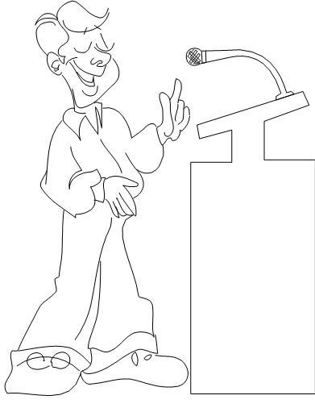
District Activity Day 4-H’ers advancing from the county level presentation, public speaking and clothing construction (fashion revue) contests are able to compete on the district level at District Activity Day. The top winners in presentations and public speaking can compete at the state level contest during 4-H Congress. State winners in sponsored categories receive cash awards. In specific categories, the state-winning seniors may go on to compete at the national level.
Contact: Shannon McCollum, shannon_mccollum@ncsu.edu

Horse Events http://www.cals.ncsu.edu/an_sci/extension/horse/Webpages/NCSU_EHH_Home.html
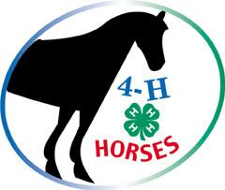
Events focused on horse education include: Equine Expressive Arts Contests, Horse Bowl, Hippology, Retreats, Horse Judging, Horse Shows and Horse Camp.
Contact: Alaina Cross, alaina_cross@ncsu.edu
Poultry Events http://www.ces.ncsu.edu/depts/poulsci/4h/index.html Events focused on poultry education include: poultry judging, NC State Fair Turkey Show, poster competition and a Poultry Science Summer Institute.
Contact: Becca Wysocky and Dannica Wall, rlbarne2@ncsu.edu, dcwall2@ncsu.edu

Electric Congress NC 4-H Electric Congress, an educational event, recognizes excellence in the Electric Program throughout the state. 4-H Electric Congress rotates from each region of the state. 4-H members participate in workshops, meet their Power Company Representatives, and interact with other electric winners. 4-H’ers must be at least 11 years old to attend. Counties may send two project winners, two cumulative record participants, one program recruiter and possibly an at-large program recruiter (10 in the state). 4-H Electric Congress is usually held in July.
Contact: Grant Ellington, grant_ellington@ncsu.edu

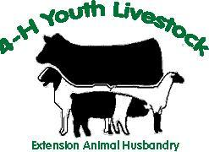
Horticulture Contest http://www.ces.ncsu.edu/depts/hort/hil/4h-index.html The Horticulture Contest may take place at NC 4-H Congress or earlier in the year. It consists of three parts, a knowledge exam, testing what you know about horticulture, an identification test of flowering annuals, vegetables, woody shrubs and trees and indoor foliage plants, and a judging section that works your skills in determining plant quality.
Contact: Liz Driscoll, liz_driscoll@ncsu.edu

Livestock Events http://www.cals.ncsu.edu/an_sci/extension/animal/4hyouth/ah4h.html Events focused on livestock education include: poster contest, livestock judging, livestock skill-a-thon, livestock quiz bowl, livestock shows and showmanship circuits, beef ambassador contest, and the Perry & Doris Teeter 4-H Beef Leadership Institute.
Contact: Brent Jennings, brent_jennings@ncsu.edu

Make It With Wool Competition This competition is open to all ages and all levels of sewing. Entries may be sewn, knitted, crocheted, woven or felted and must contain wool or wool blend (minimum 60% wool, mohair, cashmere, alpaca, camel, llama and/or vicuna). Contestants must select, construct and model the garment themselves. Contact: Jean Thomas (704) 807-6683 Ejthom41@bellsouth.net
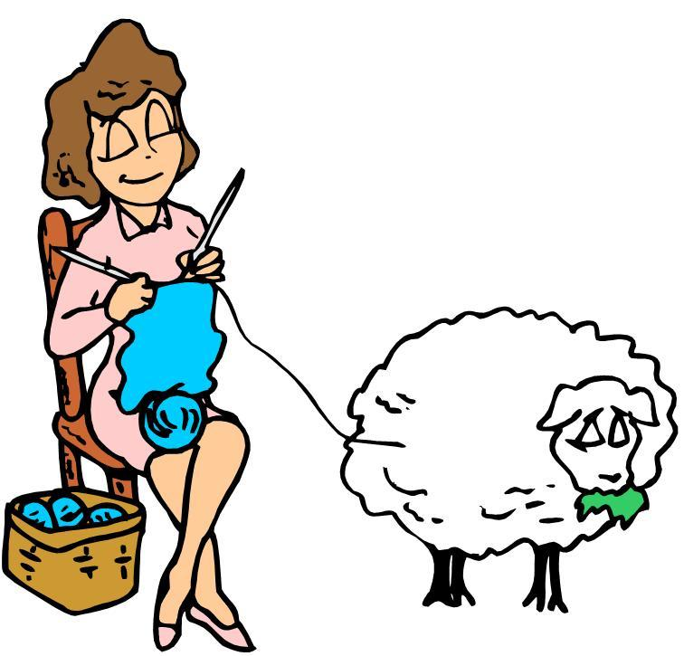
NC 4-H Congress http://www.nc4h.org/youth/congress/ Normally held in July, NC 4-H Congress is a four day culminating event event for the 4-H year. The event is geared for teen 4-H’ers ages 13-18; however, junior 4-H’ers may attend part-time if they were named district presentation winners. Congress is held on the campus of NC State University. Activities of the week include: state presentation finals, Honor Club tapping, state-level hands-to-service project, State 4-H Council officer elections, banquets, dances, engaging workshops, and more. Presentation contest happens on Saturday morning and Congress begins Saturday afternoon.
Contact: Sarah Kotzian, sarah_kotzian@ncsu.edu

NC 4-H Honor Club http://www.nc4h.org/alumni/honorclub/index.html 4-H’er must be at least 16 years old as of January 1 to apply. Membership is based on a point system involving community service, 4-H activities, leadership and citizenship. Applications due in the State 4-H Office by February 1.
Contact: Shannon McCollum, shannon_mccollum@ncsu.edu

Shooting Sports Program The 4-H Shooting Sports program strives to develop life skills through participation, learning, and competition in the shooting sports including rifle, shotgun, archery, muzzle loading, pistol, and hunting. The program is based in county clubs that can participate in competition and other learning activities on local, regional, state and national levels. Contact: Charles Young, Charles_Young@ncsu.edu

State 4-H Project Award http://www.nc4h.org/youth/statecouncil/ This award changes each year with the state 4-H project theme. These awards are generally due in July to the State 4-H office and are presented during NC 4-H Congress.
Contact: Sarah Kotzian, sarah_kotzian@ncsu.edu

State Photo Contest http://www.cals.ncsu.edu/agcomm/4-HPhoto/ The purpose of the state photo contest is to provide a showcase of 4-H members' photographic accomplishments. The exhibit is unveiled at 4-H Congress and winning photos are displayed at events throughout the year. Youth will utilize their skills and their artistry to capture their view of America and patriotism.
Contact: Becky Kirkland, rebecca_kirkland@ncsu.edu

State 4-H Council Conference This event is usually held in November as the kick-off event introducing the new state theme to 4-H members. Workshops and activities are taught by district and state officers as well as outside presenters and focus on the state theme.
Contact: Sarah Kotzian, sarah_kotzian@ncsu.edu

State 4-H Council Officers http://www.nc4h.org/youth/statecouncil/ A 4-H member is eligible to run for State 4-H Office if he or she is at least 16 years of age as of January 1 of the year of nomination, and if he or she has been an active 4-H member for at least three years prior to seeking office.
Contact: Sarah Kotzian, sarah_kotzian@ncsu.edu

District 4-H Officers http://www.nc4h.org/youth/statecouncil/ Candidates for district office must be at least 14 years old and have been an active 4-H member for at least two years. A person may only serve as a district officer once.
Contact: Sarah Kotzian, sarah_kotzian@ncsu.edu

Teen Retreats The NC State 4-H Program is divided into five districts: West, North Central, South Central, Northeast and Southeast. District officers from each district help plan this district-wide 4-H event held in the spring. This leadership building retreat offers training and workshops centering on the state 4-H project for 4-H’ers ages 13 to 18. District teen council officers are elected either at Teen Retreat or District Activity Day, depending on the district.
Contact: Sarah Kotzian, sarah_kotzian@ncsu.edu and District Agent Advisors – rotates.

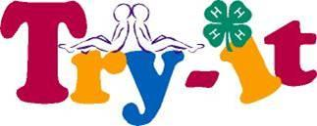
TRY (Teens Reaching Youth) http://www.ces.ncsu.edu/depts/fourh/old/try-it/index.htm provides an opportunity for 4-H teens to become teachers/facilitators by completing required training at a basic TRY retreat. Teams of three to four 4-H teens and one adult volunteer receive specific training to become certified members. TRY teams utilize their skills to teach specific curricula to younger youth in their counties.
Contact: Shannon McCollum, shannon_mccollum@ncsu.edu

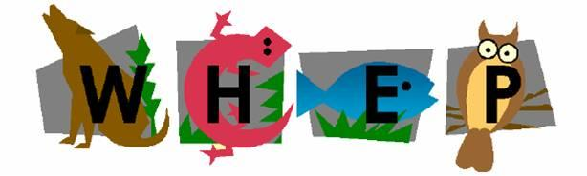
Wildlife Habitat Evaluation Program http://forestry.ces.ncsu.edu/4h/ WHEP is a 4-H youth natural resource program dedicated to teaching wildlife and fisheries habitat management to junior and senior level youth.
Contact: Renee Strnad, renee_strnad@ncsu.edu

Youth Volunteer Awards http://www.nc4h.org/youth/4-h-teen-programs District and State 4-H Youth Volunteer Awards are presented at State 4-H Council Conference to individuals who have demonstrated outstanding leadership and volunteer service.
Contact: Sarah Kotzian, sarah_kotzian@ncsu.edu
4-H Achievement Plan The 4-H Achievement Plan allows 4-H members to set goals, make plans to achieve those goals, and evaluate efforts and accomplishments that they have achieved through 4-H. Throughout this plan, service to others, as well as creativity, responsibility, and leadership are important. This plan encompasses four achievement levels: green, bronze, silver, and gold.
Contact: Shannon McCollum, shannon_mccollum@ncsu.edu
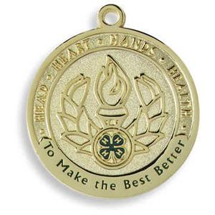
County Activity Day County Activity Day is the county presentation competition that is held to determine who advances to District Activity Day in presentations. A talent showcase is also held to determine our county participants for 4-H Entertains.
Contact: Local 4-H Agent

Public Speaking Contest The Public Speaking contest is the county competition to determine which 4-H’ers will advance to District Activity Day. 4-H’ers who win in both presentations and public speaking on the county level can only compete in one of these competitions on the district level at District Activity Day, NOT BOTH.
Contact: Local 4-H Agent

County Council County Council is comprised of officers from all 4-H Clubs in the county. County Council members help plan county events and keep their respective clubs informed of county events.
Contact: Local 4-H Agent
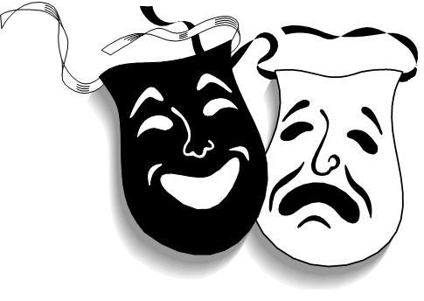
Expressive Arts The Expressive Arts Contests allows youth to prepare for entering artistic items in the local Fairs and other 4-H state level contests.
Contact: Local 4-H Agent

State Fair 4-H Opportunities The North Carolina State Fair provides 4-H’ers with a wonderful opportunity to market 4-H and their county by participating in the 4-H Crafts, 4-H Photography, 4-H Hay Bale Decorating, 4-H Entomology and each Extension District with opportunities to exhibit their 4-H skills and talents. There are premium offered to the winners in each area. 4-H’ers must pre-register through the fair.
Contact: Shannon McCollum, shannon_mccollum@ncsu.edu

4-H Volunteer Opportunities
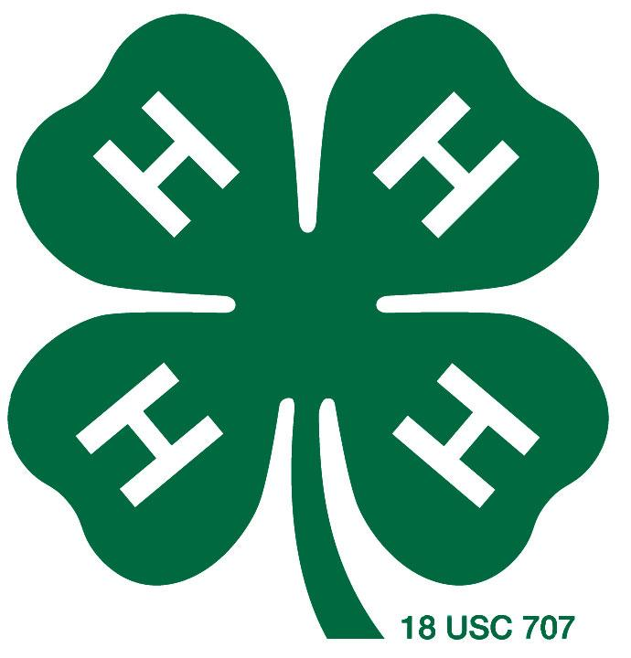

NC 4-H Volunteer Leaders’ Association http://www.nc4h.org/volunteers/ There are county, district and state leaders association that 4-H volunteers can participate in. This association provides opportunities for county, district and state level trainings and the association offers scholarships for 4-H youth. There is also the potential for leadership development by serving as a county, district or state officer.
Contact: Sarah Kotzian, sarah_kotzian@ncsu.edu
NC 4-H Volunteer Leaders’ Conference http://www.nc4h.org/volunteers/ Normally held in February, this conference provides an opportunity for volunteer leaders to come together, participate in workshops and training, elect new State Association Officers, and recognize the accomplishments of our 4-H Volunteers. Contact: Sarah Kotzian, sarah_kotzian@ncsu.edu

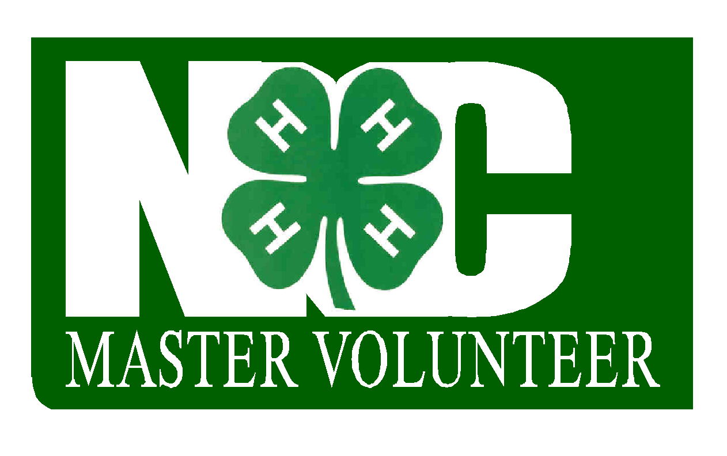
NC 4-H Master Volunteer Achievement in Continuing Education http://www.nc4h.org/volunteers/ The NC 4-H Master Volunteer ACE program is designed to assist volunteers in the development of specialized skills as 4-H volunteers by participating in quality training experiences, processing learning experiences, conducting service activities/projects, and developing a Master Volunteer ACE portfolio.
Contact: Sarah Kotzian, sarah_kotzian@ncsu.edu

Volunteer Conference of Southern States The primary purpose of the VCSS is to educate and prepare volunteers to share the information acquired at the forum with their own 4-H programs and activities. Participants benefit from the experiential learning activities that require them to discuss, use, and apply what they learn. The ultimate application is for individuals and teams to teach others. This event is held annually in October at Rock Eagle 4-H Center in Eatonton, Georgia.
Contact: Harriett Edwards, harriett_edwards@ncsu.edu

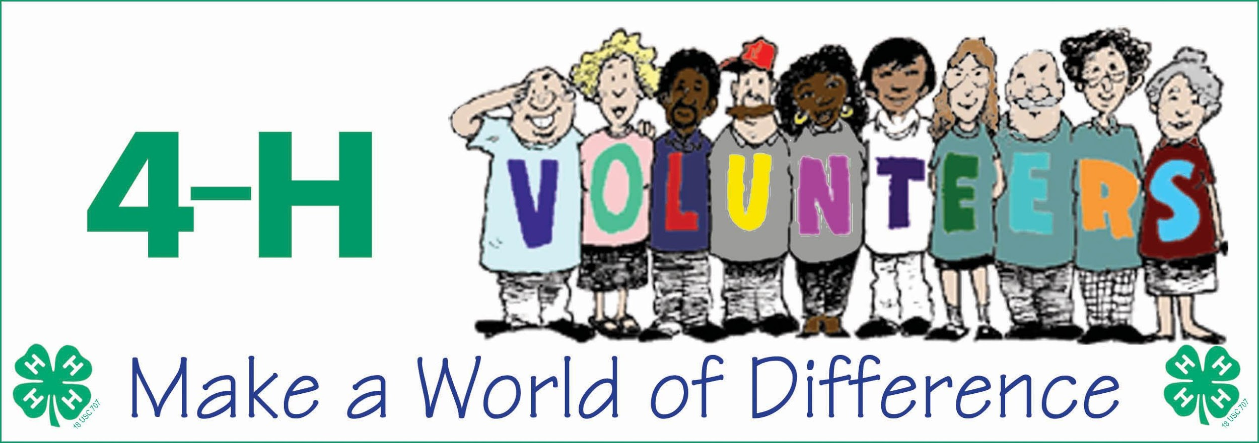
Volunteer Leader Recognition http://www.nc4h.org/volunteers/ The NC 4-H Volunteer Leaders’ Association (VLA) annually sponsors a statewide volunteer recognition program to formally acknowledge the excellent work of these individuals who give their time, talents and resources in support of the youth participating in North Carolina 4-H programs. Nominations are typically due in December.
Contact: Sarah Kotzian, sarah_kotzian@ncsu.edu

This document was originally developed by 4-H Agents in North Carolina (updated Feb. 1, 2017)

