LAMB PROJECT
11-12 YEAR OLDS

SECTION I PROJECT INFORMATION

- What date was your lamb put on feed?
_____________________________

- What was its beginning weight?
_____________________________

- What was its final weight on show day?
_____________________________

- What was its average daily gain? (Final weight minus beginning weight, divided by the number of days you fed it)
_____________________________

- What breed is your lamb?
_____________________________

6. Include a picture of your lamb on the back of this page.

SECTION II EXPERIENCE

- What type of feed did you use?

Home Mix _________ Commercial Company _________

2. What are the main ingredients in this feed? ______________________________________________________________
______________________________________________________________

3. What kind of hay did you feed? _______________________________

- How many times per day did you feed? _______________________________

- How much grain and hay did you feed each day? _______________________

- What was the total cost of your grain? _______________________

hay? _______________________

- Did your lamb have access to clean water every day? ___________________

- Was your lamb ever sick? _________ If yes, did you medicate it? _________ How much did it cost? _________

- Did you deworm your lamb? _________ If yes, what did you use? _________ How much did it cost? ____________

- On average, how much time did you spend working with your lamb each week? ________________________________________________________

- Did you buy any equipment for this project? _________ If yes, what did you buy and how much did it cost? __________________________________

SECTION III SHOW RECORD

- What was the date of the show? ______________________

- How did your lamb place in its market class? ____________

Was your lamb Grand or Reserve Champion? ___________

- Did you place in the showmanship competition? _________ If so, what was your placing? _________

- How much did your animal bring at the auction sale? ____________________

- How much did you receive for your lamb from the market? ______________

- What was your total income? (add lines 4 & 5) _______________________

7. What was your net income? (subtract total cost from total income) _________

SECTION IV KNOWLEDGE

- What part of the feed provides energy for your lamb? ____________________

- Which animal needs more protein, a ram or a lactating ewe? ______________________________________________________________

- List 2 common health problems sheep can have:

a._____________________________________________________________

b._____________________________________________________________

4. List 3 breeds of sheep and identify at least one characteristic that distinguishes them from other breeds of sheep:

a._____________________________________________________________

b._____________________________________________________________

c._____________________________________________________________

5. Define the following terms:

a. Fleece ______________________________________________________

______________________________________________________________

b. Vaccination __________________________________________________

______________________________________________________________

c. Soremouth ___________________________________________________

______________________________________________________________

d. Parasite _____________________________________________________

______________________________________________________________

e. Enterotoxemia_________________________________________________

______________________________________________________________

- Name the parts of the lamb’s digestive tract:

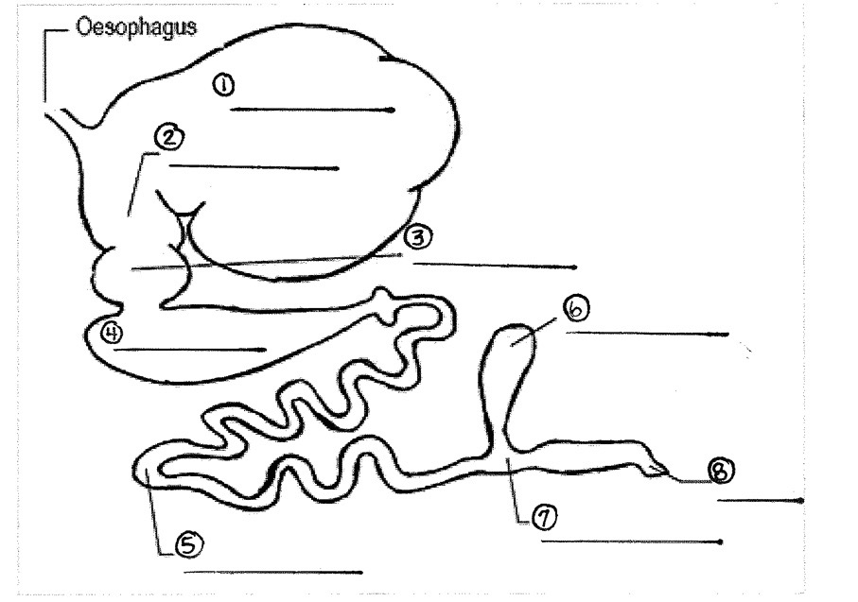

Large Intestines Omasum
Abomasum Caecum
Rectum Small Intestines
Rumen Reticulum

