Lamb/Goat Showmanship Questions

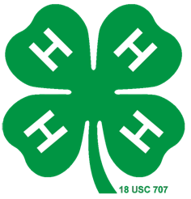

1. What is the breed of your lamb or goat? ___________________________________________

2. The 2019 Tyrrell County 4-H Livestock Show and Sale will be held on which date?
a. Wednesday, April 17, 2019
b. Monday, April 23, 2018
c. Wednesday, April 18, 2019
d. Friday, April 27, 2018

3. The following pictures are an example of which view of your animal? ___________________
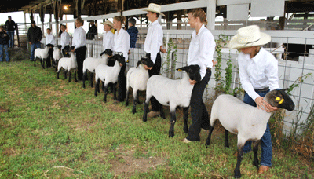
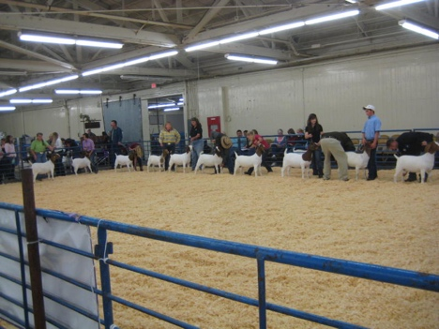

4. How is average daily gain calculated? _____________________________________________

______________________________________________________________________________

5. Loose salt and minerals should be provided for goats and lambs. Cattle mineral should not be used for lambs because of high amounts of what mineral?
a. Zinc
b. Copper
c. Manganese
d. Potassium

6. Spending time with your animal is important. You should practice walking and halter breaking your animal every other day. TRUE or FALSE (circle one)

7. You should wear clean dress pants or jeans with _______________ for the show.

8. The 2019 sale order will go as followed.
a. Hog, Lamb, Goat
b. Lamb, Hog, Goat
c. Goat, Lamb, Hog
d. Goat, Hog, Lamb

9. What disease causes scabs or blisters around the mouth?
a. Ringworm
b. Leptospirosis
c. Soremouth
d. White Muscle Disease

10. _______________ should be provided to your animal at all times.

11. You can stop showing your animal as soon as the judge stops looking at you or turns away.
TRUE or FALSE (circle one)

12. The judge should always have at least a partial view of your animal.
TRUE or False (circle one)

13. What type of feed are you feeding your animal? ___________________________________

______________________________________________________________________________

14. If your project book is late, how much will your check be docked?
a. $5 per day
b. $2 per week
c. $5 per business day
d. $15 per week

15. Answer the following question that applies to your animal.
-All lambs must be wormed and receive a/an _____________________________ shot.
-All goats must be wormed and have a/an _______________________________ .

16. Each exhibitor is expected to contact ________ buyers before _______________________.

17. Place your animals legs _________________ beneath them with each leg at the _________ corners of their body.

18. It is important to keep good spacing between you and another showmen.
TRUE or FALSE (circle one)

19. The following is an example of which view of your animal. ___________________________

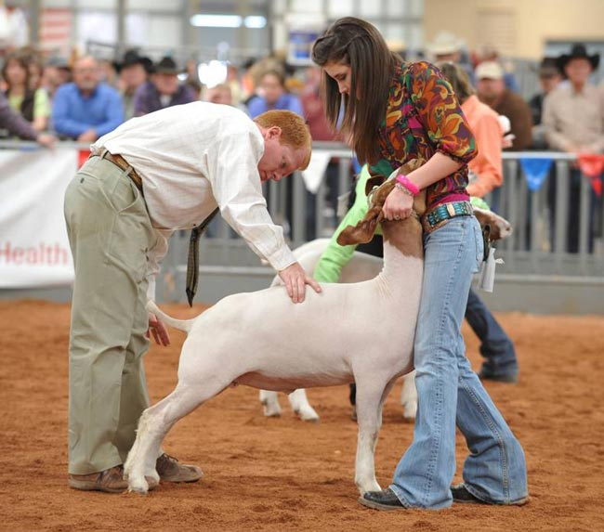
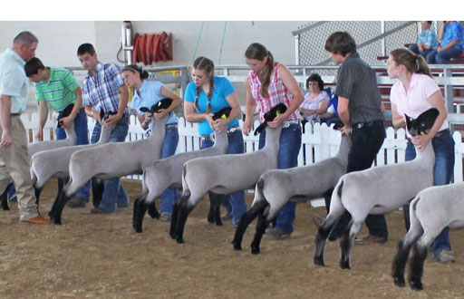

20. Why is it important to keep your animal’s pen clean and dry? _________________________

______________________________________________________________________________

21. It is better to feed your animal twice a day instead of using a self -feeder.
TRUE or FALSE (circle one)

22. List 3 things that can be a sign of illness. __________________________________________

______________________________________________________________________________

23. State law requires that the animals must be paid for within ________ days after separation from their herd and has a scrapie tag on the animal.

24. A Thank You letter and completed project book will be due in the Extension Office Friday, May 11, 2018. True or False (circle one)

25. In order to compete in showmanship you must ___________________________________.

Choose the Goat or Lamb activity and label the parts on the next page. Choose the animal you will be showing.
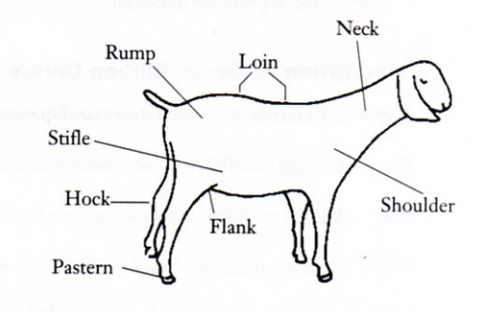
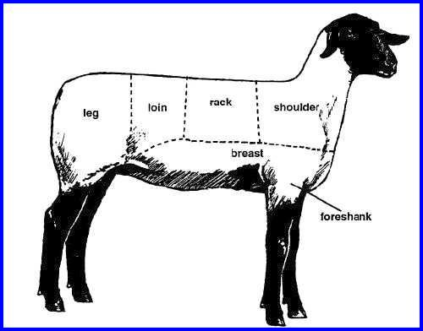

Lamb Key Goat Key

A. Breast A. Pastern
B. Loin B. Shoulder
C. Foreshank C. Flank
D. Shoulder D. Loin
E. Leg E. Neck
F. Rack F. Stifle
G. Rump
H. Hock

