GOAT PROJECT
9-10 YEAR OLDS

SECTION I PROJECT INFORMATION

- When was your goat put on feed?
_____________________________

- What was its beginning weight?
_____________________________

- What was its final weight on show day?
_____________________________

4. What is the breed of your goat?
_____________________________

5. Include a picture of your animal on the back of this page.

SECTION II EXPERIENCE

- What type of grain mix did you feed your goat?

Home mix: ____________ Commercial mix: ____________

2. What kind of hay did you feed? _____________________________________

- How many times per day did you feed? _______________________________

4. Was your goat ever sick? ____________ If yes, what did you do? ______________________________________________________________

5. Did you deworm your goat? ____________

6. Did you buy any equipment for this project? ____________ If yes, what was it and how much did it cost? _________________________________________

7. Did your goat place in its class? ____________

8. How much did your goat sell for at the auction? ____________

SECTION III KNOWLEDGE

1. List 3 breeds of goats:

a._________________________________________________________

b._________________________________________________________

c._________________________________________________________

2. Define the following words:

a. Chevon ______________________________________________________

b. Mohair ______________________________________________________

c. Cud _________________________________________________________

d. Dehorning ___________________________________________________

3. What was the best and worst part of this project?

______________________________________________________________

______________________________________________________________

______________________________________________________________

4. List the body parts of the goat below:

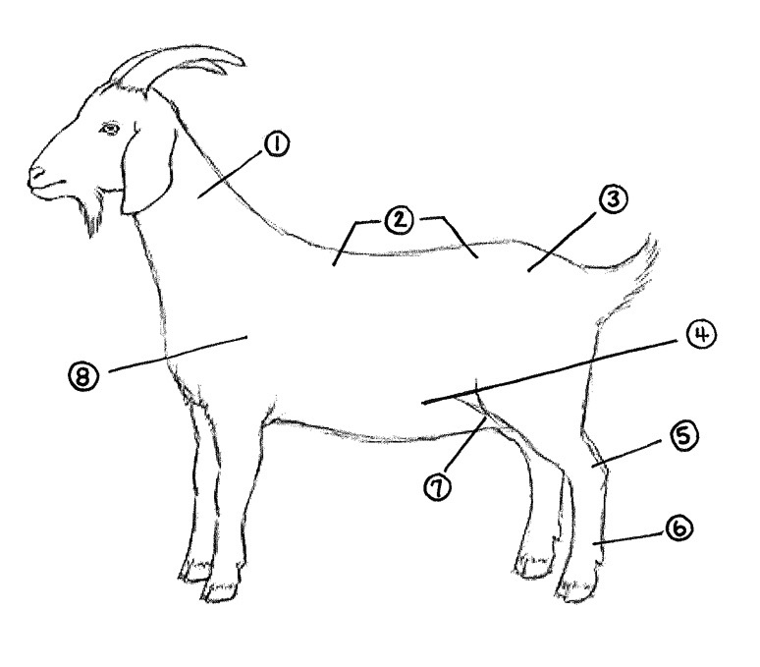

1._________________________ 5._________________________

2._________________________ 6._________________________

3._________________________ 7._________________________

4._________________________ 8.________________________

