HOG PROJECT
11-12 YEAR OLDS

SECTION I PROJECT INFORMATION

- What date was your hog put on feed?
_____________________________

- What was its beginning weight?
_____________________________

- What was its final weight on show day?
_____________________________

- What was its average daily gain? (Final weight minus beginning weight, divided by the number of days you fed it)
_____________________________

- What breed is your hog?
_____________________________

- Was your hog a gilt ________, or a barrow ________?

7. Include a picture of your hog on the back of this page.

SECTION II EXPERIENCE

A. FEED AND HEALTH RECORD

- What type of feed did you use?

Home mix _________ Commercial Company _________

2. What are the main ingredients in this feed? ______________________________________________________________
______________________________________________________________

- How many times per day did you feed your hog? ____________

4. How much did you feed your hog each day? __________________________

5. What was the total cost of your feed? ________________________________

- Did your hog have access to vitamins, minerals and salt? ________________

- Did your hog have access to fresh water every day? ____________________
- Was your hog sick at any time? ____________ If so, did you medicate it? ____________If yes, what did you use and how much? __________________

- Did you buy any equipment for this project? ____________ If so, what did you buy? __________________________________________________________

10. On average, how much time did you spend working with your hog each week? ________________________________________________________

B. SHOW RECORD

- What was the date of the show? _______________________

- How did your hog place in its market class? _____________

Was your hog Grand or Reserve Champion? ___________

- Did you place in the showmanship competition? _________ If so, what was your placing? _________

- How much did you receive for your hog at the auction? __________________

- What was the total income from the sale of your hog? (add auction price with the packer’s support price) ________________________________________

- What was your net income?
Total Sale Income (no. 5) _______________________
Minus Total Costs _______________________

Net Income _______________________

SECTION III KNOWLEDGE

- What part of the feed provides energy for your hog? ______________

- Which animal needs more protein, a nursery pig or a top hog? ______________________________________________________________

- Which animal requires more total digestible nutrients, a gestating sow or a lactating show?
______________________________________________________________

4. List two grains, other than corn, that can be used in hog rations: ___________
______________________________________________________________

5. What product is usually the protein source in a hog ration? _______________

6. List two external parasites and how you would treat a hog for them: ________

______________________________________________________________

______________________________________________________________

7. List 3 ways to deworm pigs:

a._________________________________________________________

b._________________________________________________________

c._________________________________________________________

8. List 5 breeds of hogs and one distinctive characteristic of each breed:

a._________________________________________________________

b._________________________________________________________

c._________________________________________________________

d._________________________________________________________

e._________________________________________________________

9. Define the following terms:

a. Coccidiosis ___________________________________________________

______________________________________________________________

b. Lysine _______________________________________________________

______________________________________________________________

c. Pseudorabies _________________________________________________

______________________________________________________________

d. Self-Feeding __________________________________________________

______________________________________________________________

e. Average Daily Gain ____________________________________________

______________________________________________________________

f. Stillbirth ______________________________________________________

______________________________________________________________

10. Explain the difference between fat-soluble and water-soluble vitamins.

______________________________________________________________
______________________________________________________________

______________________________________________________________

11. Identify the parts of a hog’s digestive system:
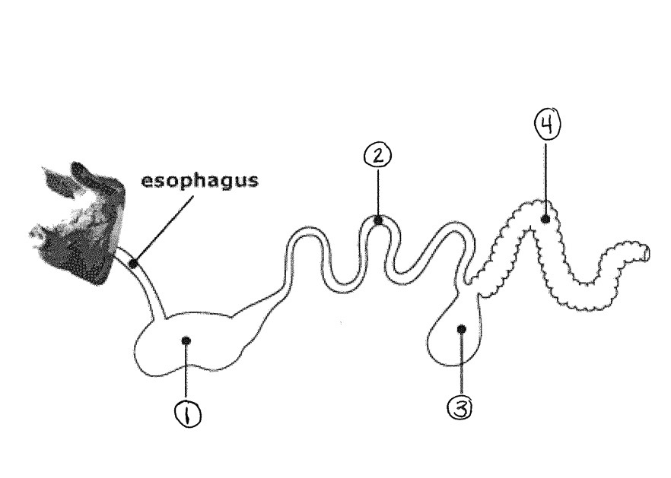

1._________________________ 2._________________________

3._________________________ 4._________________________

