2018 Scuppernong River Festival
Local Foods Culinary Arts Contest
Sponsored By:
Tyrrell County Extension & Community Association
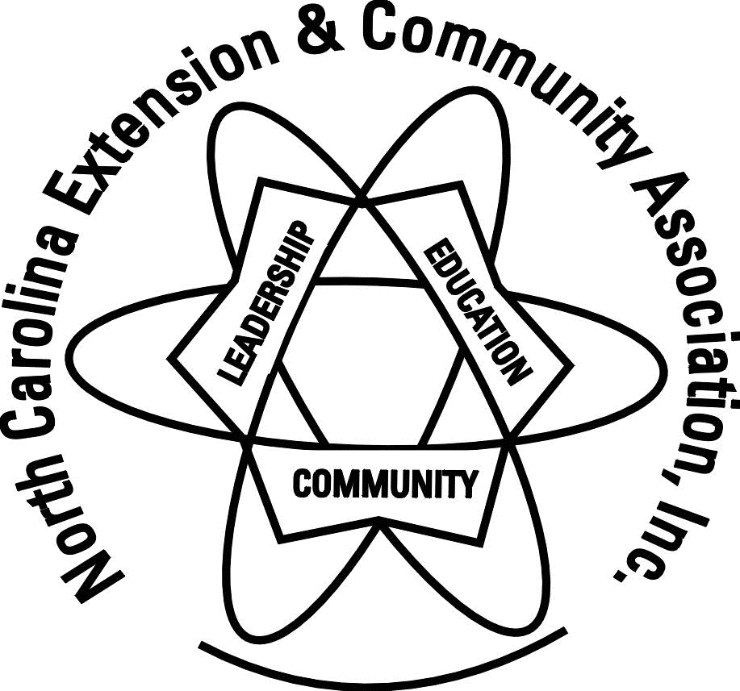

October 12, 2018

Contest Rules:
  - Participant must be at least 6 years old.
  - Participant should deliver entry(s) to the Tyrrell County Cooperative Extension Center, 407 Martha Street, Columbia on or before Friday, October 12 between the hours of 8 am and 12 noon.
  - All canned goods must be in approved half pint, pint or quart canning jars, with new jar lids.
  - Home canned goods to be judged must have been prepared within a one-year period prior to judging date.
  - Do not submit items that must be kept refrigerated.

General Information:
- Judges will select the winners in each category and age division after 12 noon on October 12, 2018 (entry deadline).
- First place in each category will receive a blue ribbon and second place will receive and a red ribbon. Grand prize winners in each age division will receive a purple ribbon. All participants will receive a green participation ribbon.
- All entries will be on display October 13 during the Scuppernong River Festival at the Information Booth.
- For more information, contact Dee Furlough at Cooperative Extension at 796-1581.
- All canned/dried goods/wines are entered at the owner’s risk and neither the Scuppernong River Festival nor Tyrrell County Cooperative Extension can assume any liability for entries.

